***Can you imagine 1,500,000 Gallons of Effluents being Dumped into PK Lake EVERYDAY***

City of Abilene’s TCEQ Renewal Permit WQ0005213000 is requesting just that!!

The Public Hearing was held June, 2024. Thanks to everyone who attended and asked questions.

Please visit the website [www.pklakeassn.org](http://www.pklakeassn.org) to see the TCEQ Executive Director’s Response to the Public Comments.

***Just imagine dumping 30 Railroad tanker loaded with effluents***

***(about 1,500,000 gallons) into PK Lake daily!***

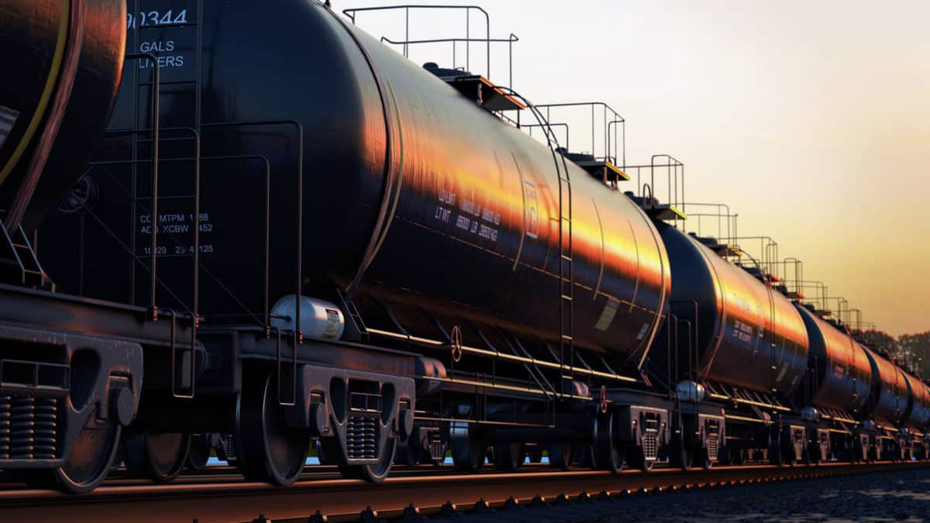

**UPDATE ON CURRENT EVENTS AS PKLA WORKS TO PROTECT**

**YOUR LAKE INVESTMENT**

* PKLA received notification on June 26, 2025 from TCEQ that we have 30 days to file for a Contested Hearing. PKLA attorneys filed necessary paperwork on July 25, 2025 for the contested hearing. All documents are available on the website.
* Once the Contested Hearing is scheduled, we will notify everyone through email.  The hearing will be held in Austin before State of Administrative Hearing (SOAH). This is a trial-like hearing heard before the SOAH Judge. Evidence is presented and the Judge makes a decision that is recommended to TCEQ Commissioners.
* PKLA has obtained attorneys and a hydrologist to prepare evidence.

PKLA will need your help as we prepare for this Contested Hearing! Please watch for the updates!